Hernán Cortés, Second Letter to the Emperor Charles V (1520)
Excerpt 1: Description of the City of Tenochtitlan
In order, most potent Sire, to convey to your Majesty a just conception of the great extent of this noble city of Temixtitlan, and of the many rare and wonderful objects it contains; of the government and dominions of Muteczuma, the sovereign; of the religious rites and customs that prevail, and the order that exists in this as well as other cities appertaining to his realm: it would require the labor of many accomplished writers, and much time for the completion of the task. I shall not be able to relate an hundredth part of what could be told respecting these matters; but I will endeavor to describe, in the best manner in my power, what I have myself seen; and imperfectly as I may succeed in the attempt, I am fully aware that the account will appear so wonderful as to be deemed scarcely worthy of credit; since even we who have seen these things with our own eyes, are yet so amazed as to be unable to comprehend their reality. But your Majesty may be assured that if there is any fault in my relation, either in regard to the present subject, or to any other matters of which I shall give your Majesty an account, it will arise from too great brevity rather than extravagance or prolixity in the details; and it seems to me but just to my Prince and Sovereign to declare the truth in the clearest manner without saying any thing that would detract from it, or add to it.
Before I begin to describe this great city and the others already mentioned, it may be well for the better understanding of the subject to say something of the configuration of Mexico, in which they are situated, it being the principal seat of Muteczuma’s power. This Province is in the form of a circle, surrounded on all sides by lofty and rugged mountains; its level surface comprises an area of about seventy leagues in circumference, including two lakes, that overspread nearly the whole valley, being navigated by boats more than fifty leagues round. One of these lakes contains fresh, and the other, which is the larger of the two, salt water. On one side of the lakes, in the middle of the valley, a range of highlands divides them from one another, with the exception of a narrow strait which lies between the highlands and the lofty sierras. This strait is a bow-shot wide, and connects the two lakes; and by this means a trade is carried on between the cities and other settlements on the lakes in canoes without the necessity of travelling by land. As the salt lake rises and falls with its tides like the sea, during the time of high water it pours into the other lake with the rapidity of a powerful stream; and on the other hand, when the tide has ebbed, the water runs from the fresh into the salt lake.
This great city of Temixtitlan [Mexico] is situated in this salt lake, and from the main land to the denser parts of it, by whichever route one chooses to enter, the distance is two leagues. There are four avenues or entrances to the city, all of which are formed by artificial causeways, two spears' length in width. The city is as large as Seville or Cordova; its streets, I speak of the principal ones, are very wide and straight; some of these, and all the inferior ones, are half land and half water, and are navigated by canoes. All the streets at intervals have openings, through which the water flows, crossing from one street to another; and at these openings, some of which are very wide, there are also very wide bridges, composed of large pieces of timber, of great strength and well put together; on many of these bridges ten horses can go abreast. Foreseeing that if the inhabitants of the city should prove treacherous, they would possess great advantages from the manner in which the city is constructed, since by removing the bridges at the entrances, and abandoning the place, they could leave us to perish by famine without our being able to reach the main land, as soon as I had entered it, I made great haste to build four brigantines, which were soon finished, and were large enough to take ashore three hundred men and the horses, whenever it should become necessary.

Hernán Cortés, Second Letter to the Emperor Charles V (1524)
Excerpt 2: Description of the Marketplace
This city has many public squares, in which are situated the markets and other places for buying and selling. There is one square twice as large as that of the city of Salamanca, surrounded by porticoes, where are daily assembled more than sixty thousand souls, engaged in buying and selling; and where are found all kinds of merchandise that the world affords, embracing the necessaries of life, as for instance articles of food, as well as jewels of gold and silver, lead, brass, copper, tin, precious stones, bones, shells, snails, and feathers. There are also exposed for sale wrought and unwrought stone, bricks burnt and unburnt, timber hewn and unhewn, of different sorts. There is a street for game, where every variety of birds in the country are sold, as fowls, partridges, quails, wild ducks, fly-catchers, widgeons, turtledoves, pigeons, reed-birds, parrots, sparrows, eagles, hawks, owls, and kestrels; they sell likewise the skins of some birds of prey, with their feathers, head, beak, and claws. There are also sold rabbits, hares, deer, and little dogs [i.e., the chihuahua], which are raised for eating. There is also an herb street, where may be obtained all sorts of roots and medicinal herbs that the country affords. There are apothecaries' shops, where prepared medicines, liquids, ointments, and plasters are sold; barbers' shops, where they wash and shave the head; and restaurateurs, that furnish food and drink at a certain price. There is also a class of men like those called in Castile porters, for carrying burdens. Wood and coal are seen in abundance, and braziers of earthenware for burning coals; mats of various kinds for beds, others of a lighter sort for seats, and for halls and bedrooms.
There are all kinds of green vegetables, especially onions, leeks, garlic, watercresses, nasturtium, borage, sorrel, artichokes, and golden thistle; fruits also of numerous descriptions, amongst which are cherries and plums, similar to those in Spain; honey and wax from bees, and from the stalks of maize, which are as sweet as the sugar-cane; honey is also extracted from the plant called maguey, which is superior to sweet or new wine; from the same plant they extract sugar and wine, which they also sell. Different kinds of cotton thread of all colors in skeins are exposed for sale in one quarter of the market, which has the appearance of the silk-market at Granada, although the former is supplied more abundantly. Painters' colors, as numerous as can be found in Spain, and as fine shades; deerskins dressed and undressed, dyed different colors; earthen-ware of a large size and excellent quality; large and small jars, jugs, pots, bricks, and endless variety of vessels, all made of fine clay, and all or most of them glazed and painted; maize or Indian corn, in the grain and in the form of bread, preferred in the grain for its flavor to that of the other islands and terra-firma; patés of birds and fish; great quantities of fish---fresh, salt, cooked and uncooked; the eggs of hens, geese, and of all the other birds I have mentioned, in great abundance, and cakes made of eggs; finally, everything that can be found throughout the whole country is sold in the markets, comprising articles so numerous that to avoid prolixity, and because their names are not retained in my memory, or are unknown to me, I shall not attempt to enumerate them.
Every kind of merchandise is sold in a particular street or quarter assigned to it exclusively, and thus the best order is preserved. They sell everything by number or measure; at least so far we have not observed them to sell anything by weight. There is a building in the great square that is used as an audience house, where ten or twelve persons, who are magistrates, sit and decide all controversies that arise in the market, and order delinquents to be punished. In the same square there are other persons who go constantly about among the people observing what is sold, and the measures used in selling; and they have been seen to break measures that were not true.

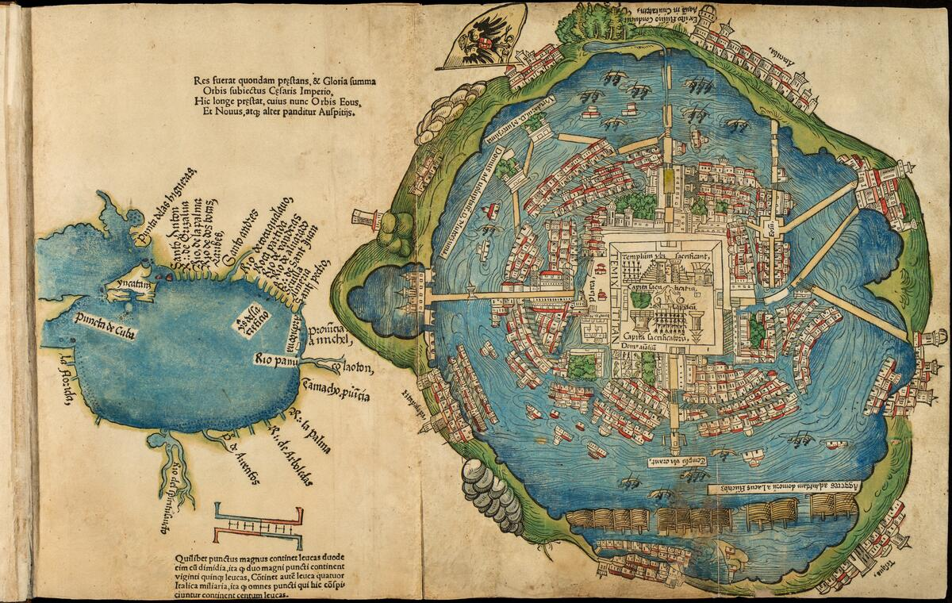
Map of Tenochtitlan (1524)

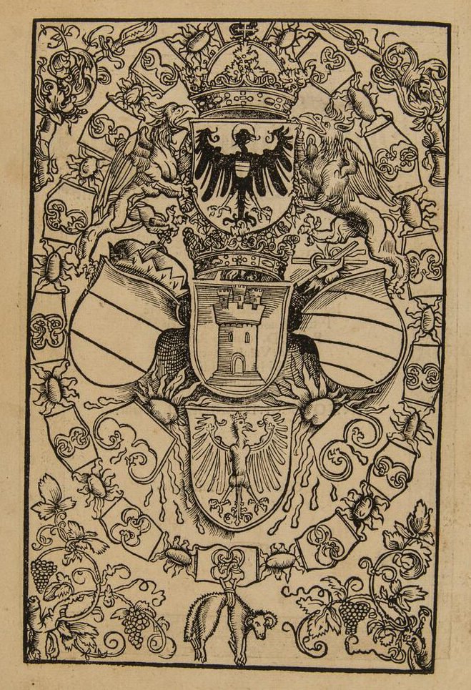
Heraldry of Charles VI (1524)
Portrait of Pope Clement VII (1524)
